The theme: My hobby.
Objectives:
-to train four types of pupils’ skills: speaking, listening, reading and writing;
- to improve oral speech habits(individual, group);
-to widen pupils’ knowledge on the topic;
-to stimulate pupils’ creative thinking;
-to enrich pupils’ vocabulary on the topic;
Equipment: a laptop, a multimedia projector, a tape recorder, a CD, an audio-cassette, cards for individual work, a presentation .
Procedure
Greeting.
-Good morning, children! I am glad to see you today! How are you today?
-Sit down girls, sit down boys. Today we have some guests. Let us smile and say good morning. What day is it today? What month is it now? What season is it now? What is the weather like today?
-The topic of our lesson is ”My hobby”(slide 1)
-So, open your copy-books and write down today’s date.
-Today we will: (slide 2)
- speak, read, listen and write about activities we do in our free time;
- make up dialogues;
- tell about your hobbies;
-practice in using Present Simple Tense
Warming up.
-Now, children, let’s revise our poem about hobby.
Everybody has a hobby
But we’ve got a common one
English does attract us
More than stamps and actors
And it’s a great fun!!!
Fill in the columns.
-Well done, thank you. Open your books on page 62. Let’s revise the words on the topic. So look at the board and write words for each column.

Hobby
To do
To learn
To collect
To make

Gardening  travelling  cycling | Handicrafts

- Good for you. Thank you. Sо, what is your hobby?
My hobby is……
Make up sentences, using the table.
- Now pupils, look at the screen and make up sentences.
-Don’t forget that to be is devided into am, is, are.(slide 3)
My mum | be interested in | learning English
Children | be good at | break dancing
I | be bad at | doing puzzles
My friend | be fond of | gardening
We | be crazy about | playing musical instruments

-OK, let’s start?
I am good at break dancing.
Children are bad at playing musical instruments.
My mum is crazy about gardening.
My friend is interested in learning English.
We are fond of doing puzzles.
Make up sentences.
-Now pupils, look at the table attentively and make up sentences as in the example.(slide 4)

musical  sporty  clever  lazy  polite  popular | has got a lot of CDs  is good at swimming and running  is interested in doing crosswords  is bad at school  says “thank you”  is a good pupil

She is musical because she has got a lot of CDs.

Listening.
-Listen and complete the dialogue.
great | hello | nice | really | well

Boy: (1)Hello, I ‘m Colin. What’s your name?
Girl: I’m Lena. I’m from Durban.
Boy: (2)Really? I’m from Sydney. What are your hobbies?
Girl: (3) Well, I paint pictures of the countryside and play the guitar.
Boy: (4)Nice. I love music. I collect rock magazines. And I take photos.
Girl: That’s (5)great. What’s your favourite sport?
Boy: Oh, I don’t play sport.
(slide 5)

-Are you ready? Let us check.
-Thank you .Now, you have to make your own dialogues changing the underlined words.(slide 6)
Boy: Hello, I ‘m Colin. What’s your name?
Girl: I’m Lena. I’m from Durban.
Boy: Really? I’m from Sydney. What are your hobbies?
Girl: Well, I paint pictures of the countryside and play the guitar.
Boy: Nice. I love music. I collect rock magazines. And I take photos.
Girl: That’s great. What’s your favourite sport?
Boy: Oh, I don’t play sport.
Checking on homework.
Speaking.
-Now, let’s check your homework. You had to prepare stories about your favourite hobbies. You can see some pictures on the board. They are really great. Who is ready to tell us about your interests?
-Let’s listen to Dasha, she will tell us about her hobby.
My hobby is sport. I like playing football, basketball, tennis. I train on Monday, Wednesday and Friday. It helps me to be sporty, strong and healthy. Also I collect stickers, listen to music, dance. My collection is about animals, flowers, Barbies. Sometimes I walk with my friends or play computer games. I am fond of travelling because it’s great. I think it is very important to have a hobby.
-Nice answer, thank you Dasha . Do you like Dasha’s hobby? Who else likes sport? Your mark is ….
-Well, Vitia, can you tell us about your interests?
I like swimming. I have got a nice swimming suit and train every day .I started it when I was 8.It is cool and good for my health. I have got many rewards. I won competitions. Also I am interested in computer games. My friends and I play them together. It’s exciting. I think my hobbies are great.
-Thank you Vitia. Do you like Vitia’s story? Your mark is….
-And Lera will tell us about her hobby.
Hi, my name is Lera. My hobby is dancing .I started it 2 years ago. I go dancing 3 times a week. I have got many beautiful costumes. I took part in different contests. My hobby helps me to be pretty, sporty and popular. Sometimes I am good at writing poems. They are about nature .I am really happy to have such interesting hobbies.
-Thank you Lera. Take your seat. Children, do you like Lera’s hobby? Your mark is …..
Relaxation.
”Head, shoulders, knees and toes”

--I think you are a bit tired and it’s time to relax. Stand up, children.
-Listen to the song and do some physical exercises.
-OK. Take your seats.
Listening.
-You will listen about pupils and their interests. Look through the tasks. Read them.
Many pupils of our school have interesting hobbies. Lara is 11 years old. She likes writing poems and painting pictures.
Tom is 15 years old and he has very interesting hobbies. He likes dancing,
designing Internet sites and playing piano.
Robert is 13 years old. His hobbies are playing football and reading detective stories. Our pupils also love different subjects. Tom is the best pupil at Maths. Lara is good at Art and Literature .And Robert is one of the best pupils at PE. Their hobbies help them study well.

Tick T(true) or F(false).

Lara’s hobby is Math.
Playing football is Robert’s hobby.
Lara is good at Art.
Robert is 15 years old.
Tom is good at Literature.
(slide 7)

Tick the correct answer.

1. How old is Robert? 13 16
2. Who has the most hobbies? Lara Tom
3. Is Tom older than Robert? Yes No
4. Who likes to play football? Robert Tom
5. Is playing piano Lara's hobby? Yes No
( slide 8)

Complete the sentences.

1. Lara is years old.
2.Tom likes designing
3. Robert is the best pupil at
4. The hobbies help them
5. Reading stories is Robert's hobby.
( slide 9)

-Nice work. Thank you!
Reading.
-So, girls and boys, it’s time for reading. You will get some papers .Your task is to read the letter and complete the text with the words from the box .
Complete the letter with the words from the box
watch | favourite | hobbies | read | funny
years old | house | pets | free | computer

Hello my friends!
My name is Susan. I am 13…(1)... I live in Oxford, Great Britain. My family is not big. I have got a mother, a father and a sister. My mother is an artist. My father is a …(2)….. programmer. We live in a big …(3)…..with a small garden. When I have …(4)… time I go for a walk, …(5)… books or …(6)….TV.I am crazy about reading different books: historical, detective and fairy-tales.
My ……(7)……. book is Tom Sawyer by Mark Twain. This book is about American Boy, his aunt and his friends. Tom is kind and …(8)….. This book teaches us to be kind and friendly. I like reading very much and you? My best friend Kate plays the piano and the guitar in a group with her friends. Also she has got two …(9)..:a kitten and a puppy. Please write me a letter about your …(10)…..
Best wishes Susan.
(slide 10)
Complete the sentences.
1. Susan lives in……………..……….
2. There are …… people in her family.
3. Her family lives in a ……….............
4. She is crazy about ………………. .
5. Susan’s favourite book is ………… .
6. The book is about ……………… boy.
7. Kate is Susan’s ……………………. .
8. Her pets are: ……………………… .
( slide 11)

Answer the questions:

1. Who is 13?
2. Who likes going for a walk?
3. Who is a computer programmer?
4. Who is an artist?
5. Who plays the musical instruments?
(slide 12)
-That’s right. Well done!!
Grammar practice.
-Look at me and let’s revise the Present Simple Tense. It is a present action .We can find this tense with the next words: always, sometimes, never, often, every day, week…, on Monday…
-When we make questions, we use DO and DOES.
(slide 13) Questions/ Write Do or Does and giveshort answers
- Do you always cook in your family? -Yes, I do.
- …she speak Italian every day? –No,… …
- … he go to the cinema on Saturdays? -Yes,… …
- … your little brother like animals? -No,… …
- … they collect coins? -Yes,… …
- … you walk in this park in the evening? -No,… …
- … Anna sing in French? - No,… …
- … Tommy love swimming? -Yes,…
(slide 13)
Crossword

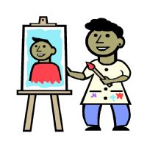
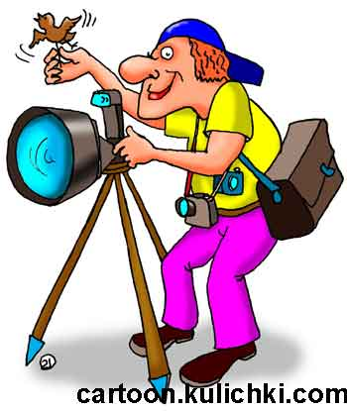
-Well, children, the next task for you is to do the crossword. (slide 14,15 )

5
6

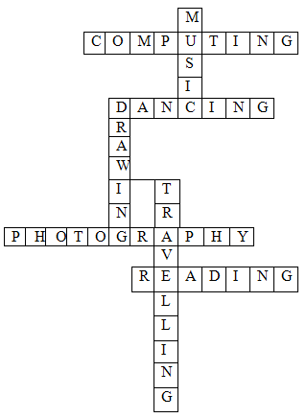
Home assignment.
-Well, your homework will be to do exercises on the copies. Write do or does and give short answers.
Summarizing.
-Thank you boys and girls, you were active today. -Your marks for today : Dasha-10,Matvey-11,Dania-11,Ira-9….. .
-So what can we do on the topic “My hobby”?
-We can read, speak…..
-Stand up ,please. The lesson is over.- Good bye children, have a nice day!!!(slide 16)

